***Understanding Callbacks and How to Respond to Events***

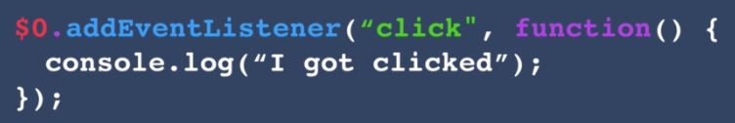

**Higher Order Functions:**

These are the functions that create to take functions as input.

Examples:

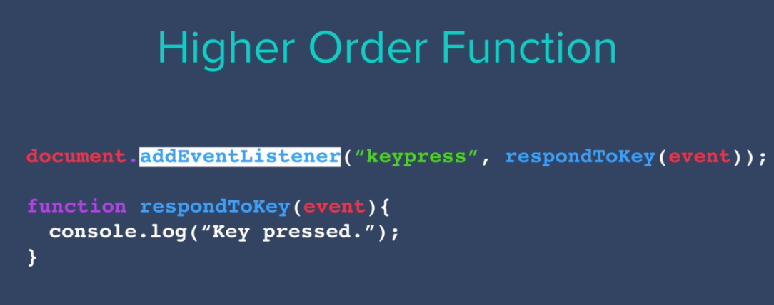

RespondToKey() is a function taken as input function.

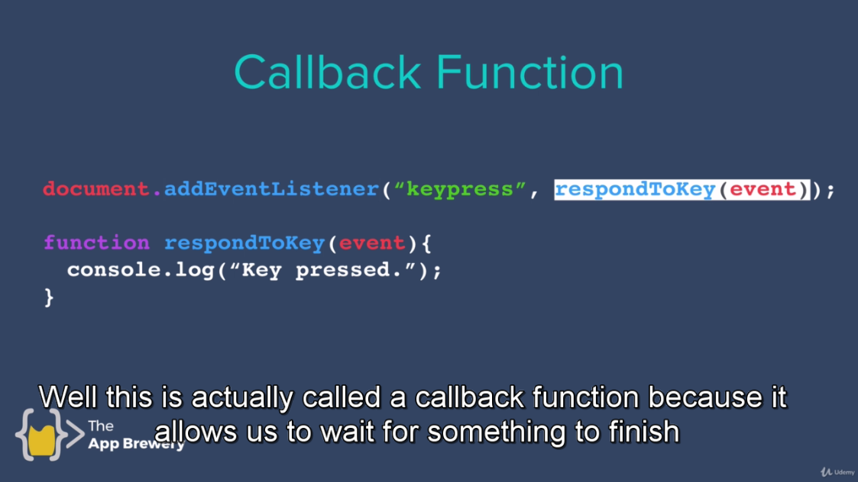

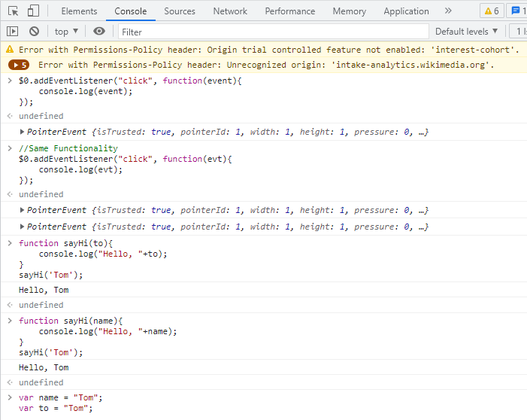

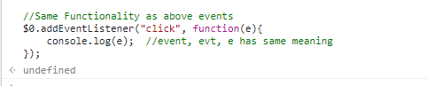

function anotherAddEventListener(typeOfEvent, callback){

// Detect Event Code....

var eventThatHappened = {

eventType: "keypress",

key: "p",

durationOfKeypress: 2

}

if(eventThatHappened.eventType === typeOfEvent){

callback(eventThatHappened);

}

}

anotherAddEventListener("keypress", function(event){

console.log(event);

});

document.addEventListener("keypress", function(event){

console.log(event);

});

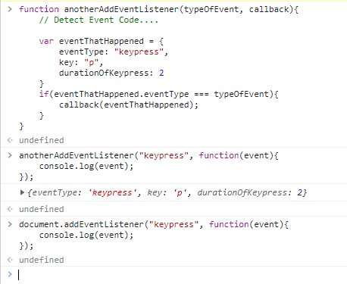

**With Debugger**

function anotherAddEventListener(typeOfEvent, callback){

// Detect Event Code....

var eventThatHappened = {

eventType: "keypress",

key: "p",

durationOfKeypress: 2

}

if(eventThatHappened.eventType === typeOfEvent){

callback(eventThatHappened);

}

}

//Use Debugger

debugger;

anotherAddEventListener("keypress", function(event){

console.log(event);

});

